Rest API

* What is Rest API?
* An API, or application programming interface, is a set of rules that define how applications or devices can connect to and communicate with each other
* How Rest API works?
* REST APIs communicate via HTTP requests to perform standard database functions like creating, reading, updating, and deleting records (also known as CRUD) within a resource. For example, a REST API would use a GET request to retrieve a record, a POST request to create one, a PUT request to update a record, and a DELETE request to delete one. All HTTP methods can be used in API calls. A well-designed REST API is similar to a website running in a web browser with built-in HTTP functionality.

Testing Endpoint (When an API interacts with another system, the touchpoints of this communication are considered endpoints. For APIs, an endpoint can include a URL of a server or service.)

In our App:

**Flask**

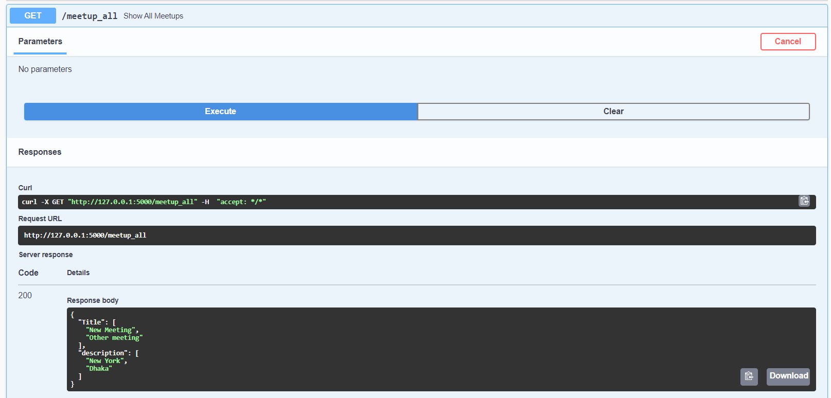

‘/meetup_all’ endpoint return a json containing list of title and description

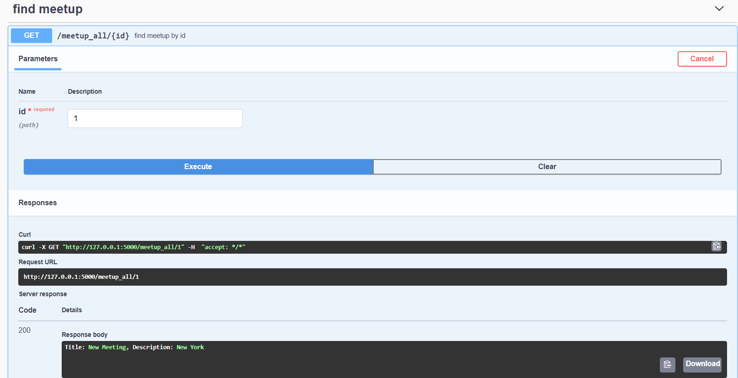

‘/meetup_all/{id}’ this endpoint returns title and description of given id, id is using as parameter to find the meetup in database.

**Django**

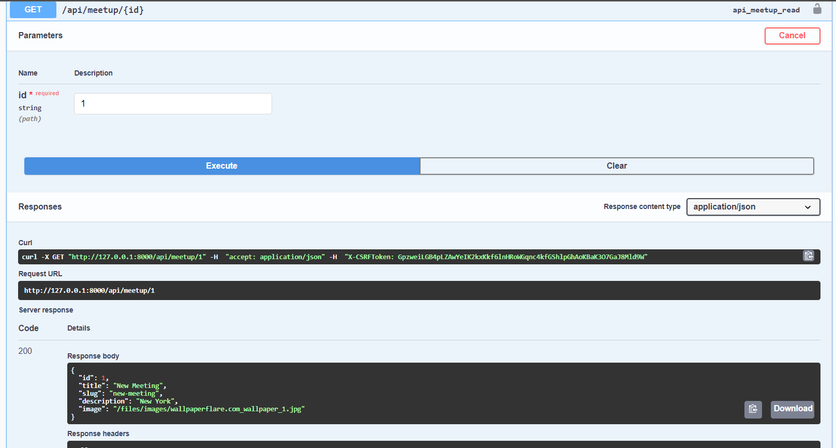

‘/api/meetup/{id}’ this endpoint return a json containing all data by given id.

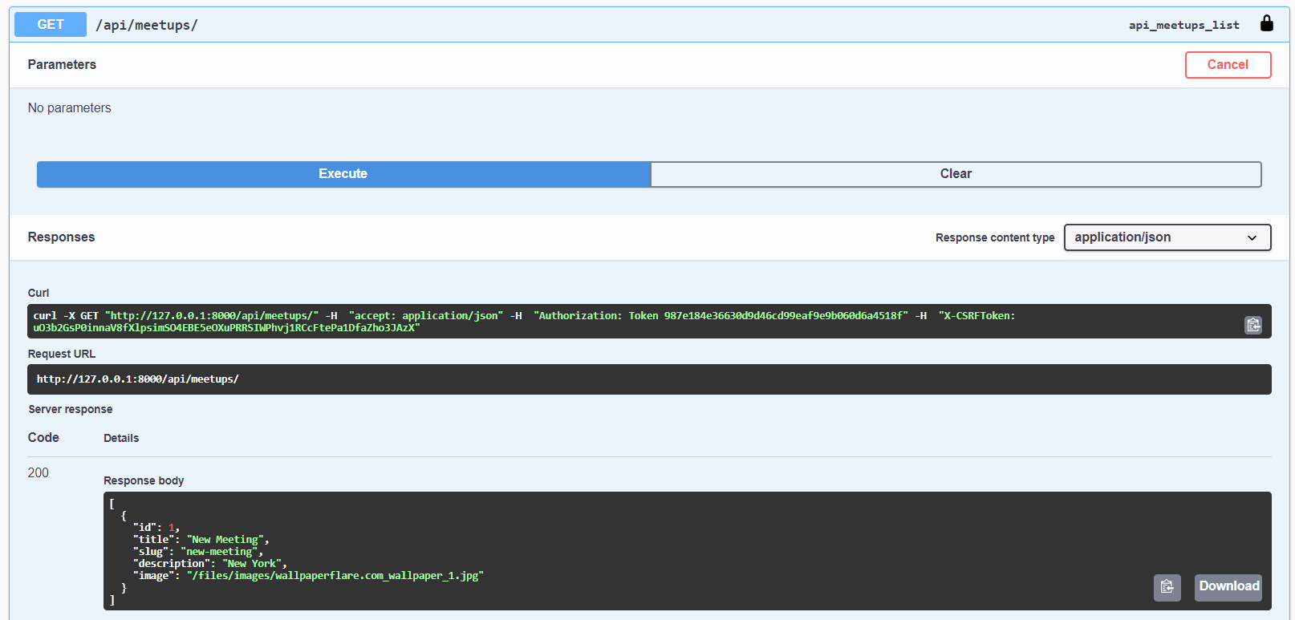

‘/api/meetups’ This Endpoint return a json containing all data from database, but for this endpoint authorization need to confirm first.

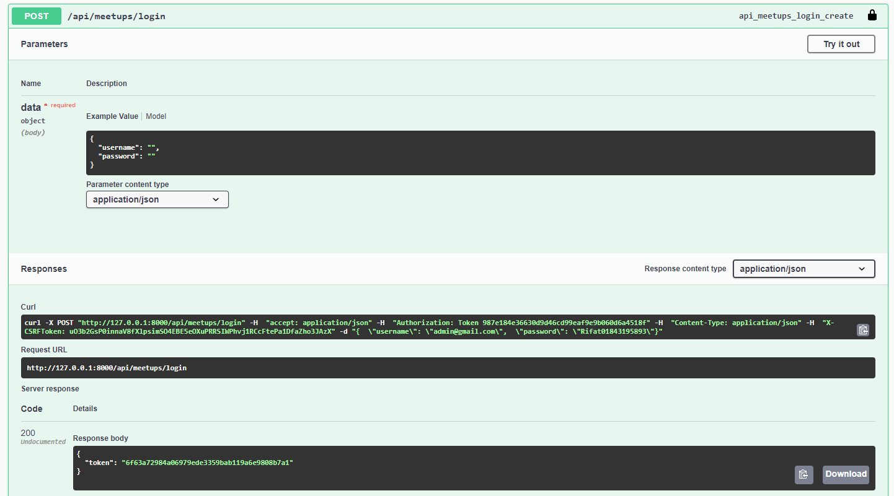

‘/api/meetups/login’ this endpoint return a token when login credentials are successful, for testing this api username(email), password need to give.

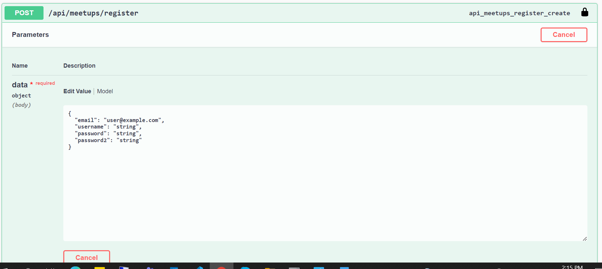

‘/api/meetups/register’ endpoint is using for register new user to Django application by default authentication, user need to give email, username, password, confirm password

Reference:

1. <https://swagger.io/tools/swagger-ui/>